8-1.Avoid_infrared
1.Preparation
1.You should learn about the position of the infrared module in the body of hellobot；
2.You should learn about the principle of the infrared obstacle avoidance.
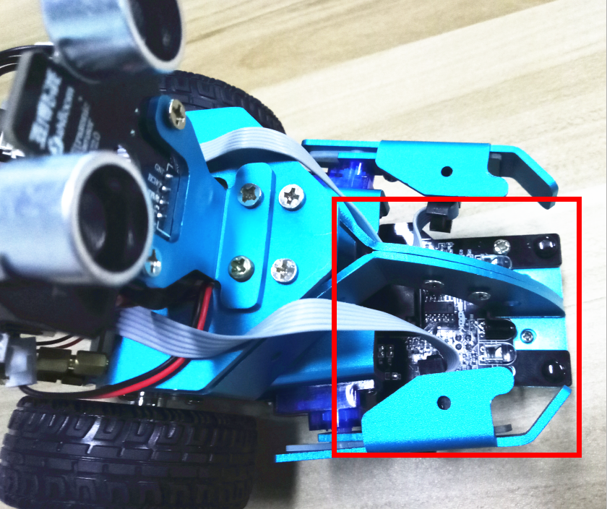
8-1-1 RGB tracking obstacle avoidance 3 in 1 module
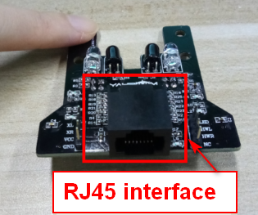
8-1-2 RJ45 interface of RGB tracking obstacle avoidance 3 in 1 module
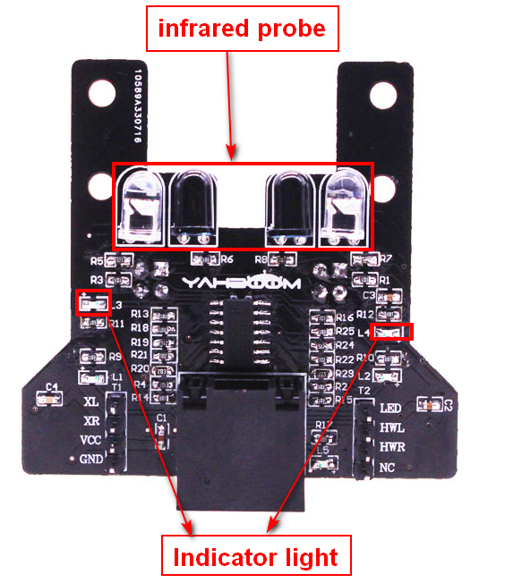
(b) infrared obstacle avoidance probe
8-1-2 RGB tracking obstacle avoidance 3 in 1 module
When there is an obstacle in front, indicator light is on, when there is not an obstacle in front, indicator light is off.
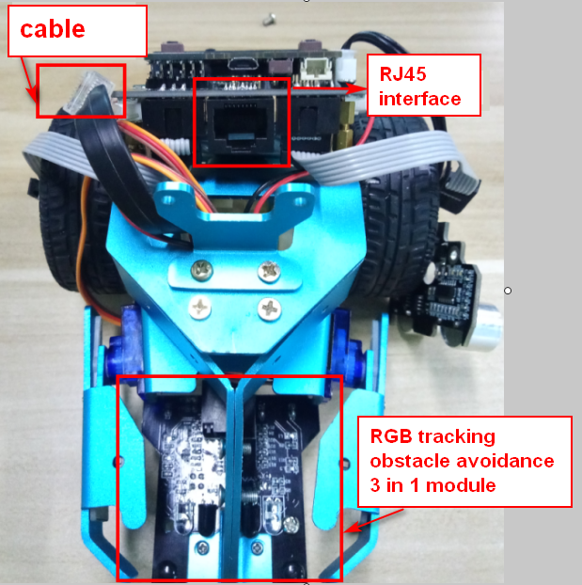
8-1-3 about wiring
The RGB tracking obstacle avoidance 3 in 1 module is installed under the robot arm of the HelloBot, and we need to use the network cable to connect the RGB tracking obstacle avoidance 3 in 1 module.
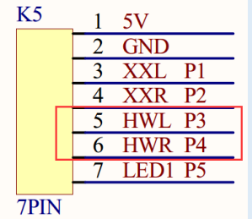
8-1-4 schematic
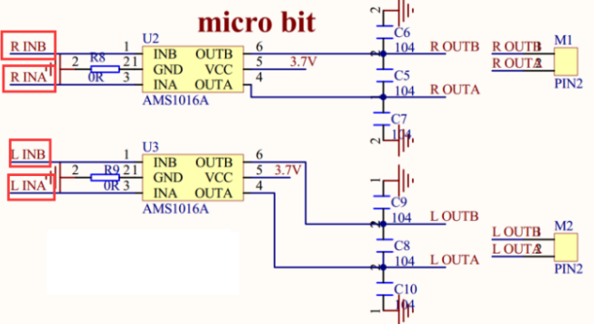
8-1-5 schematic of motor drive
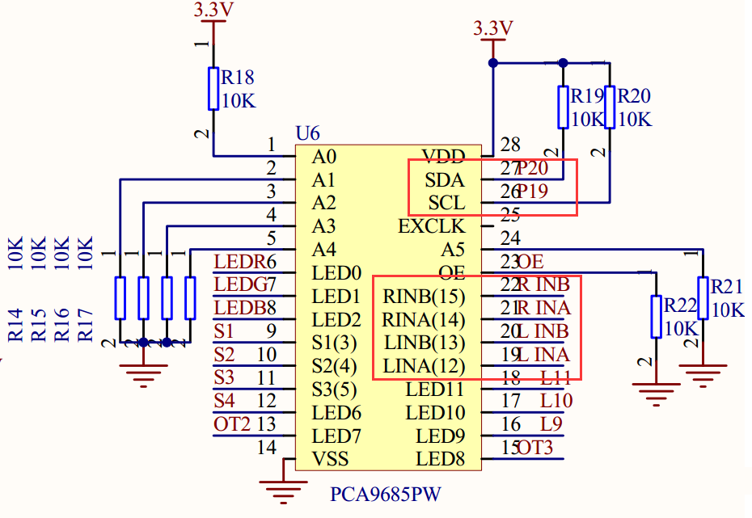
8-1-6 schematic of PCA9685PW
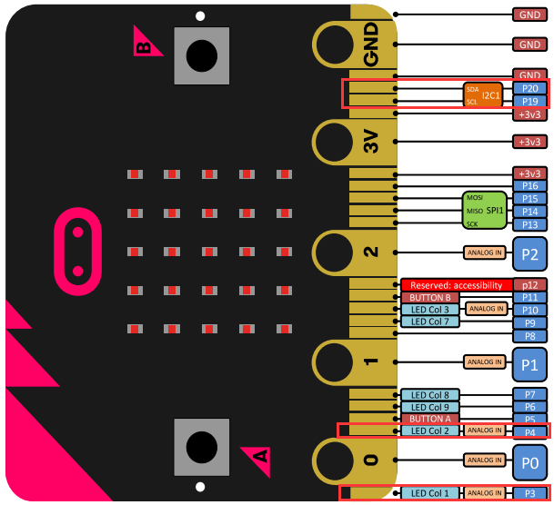
8-1-7 Pins of Micro:bit
From the schematic diagram. You can see that Pin _Trig of ultrasonic module(SCL) is connected to P3 of Micro:bit, Pin_Echo of ultrasonic module(SDA) connected to P4 of Micro:bit.
PCA9685PW connects micro:bit P19 and P20 pins for I2C communication.
Principle of infrared obstacle avoidance:
The basic principle of the infrared sensor to avoid obstacles is to use the reflective nature of the object. Within a certain range, if there is an obstacle, the infrared rays will encounter obstacle and will be reflected to reach the sensor receiving pin.
! Note:
The infrared obstacle avoidance sensor use pins P3 and P4 of micro:bit . They are multiplexed with the pins of the micro:bit LED dot matrix. Before using these functions, we can use microbit.display.off() to turn off the micro:bit LED dot matrix display.

Note:The infrared obstacle avoidance sensor is not working properly due to the interference of outdoor light. This course needs to be carried out indoors and the curtains are covered to block the outdoor light.
2.Learning goals
In this experiment, we will study how to make HelloBot realize infrared obstacle avoidance function.
3.Programming
3.1 Programming online
You can enter the URL directly in your browser: http://python.microbit.org/v/1 to enter programming online interface.
3.2 Programming offline
1) You can double-click to use it. As shown in the following figure.
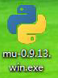
2) After entering the programming interface.
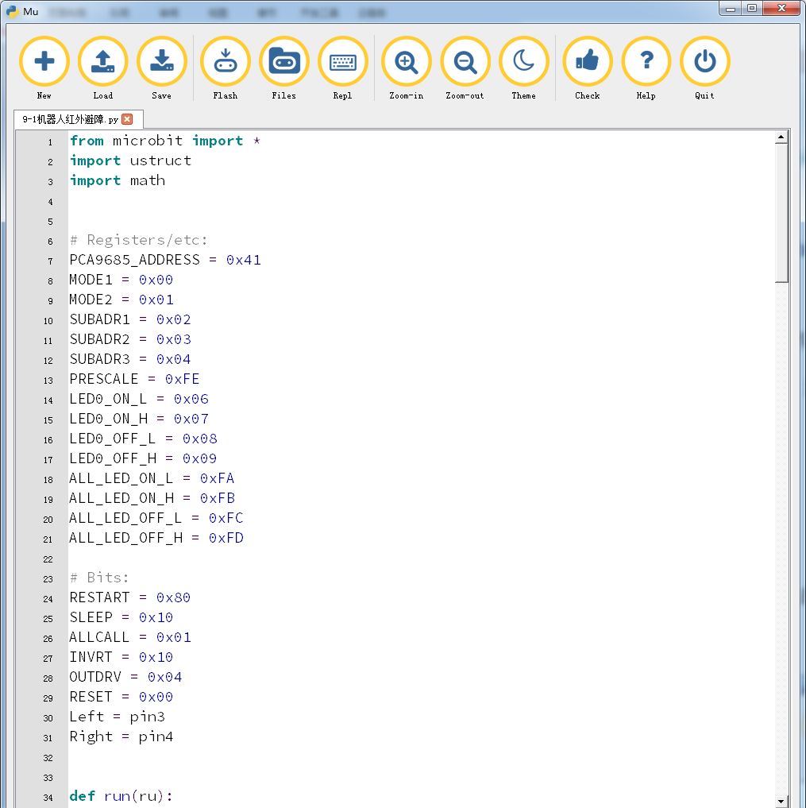
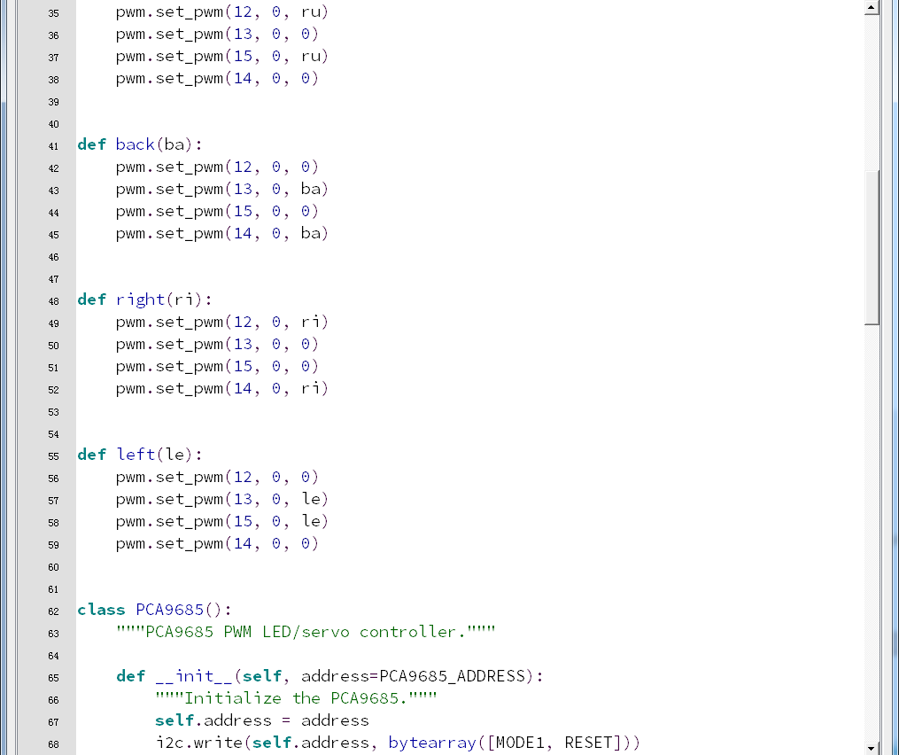
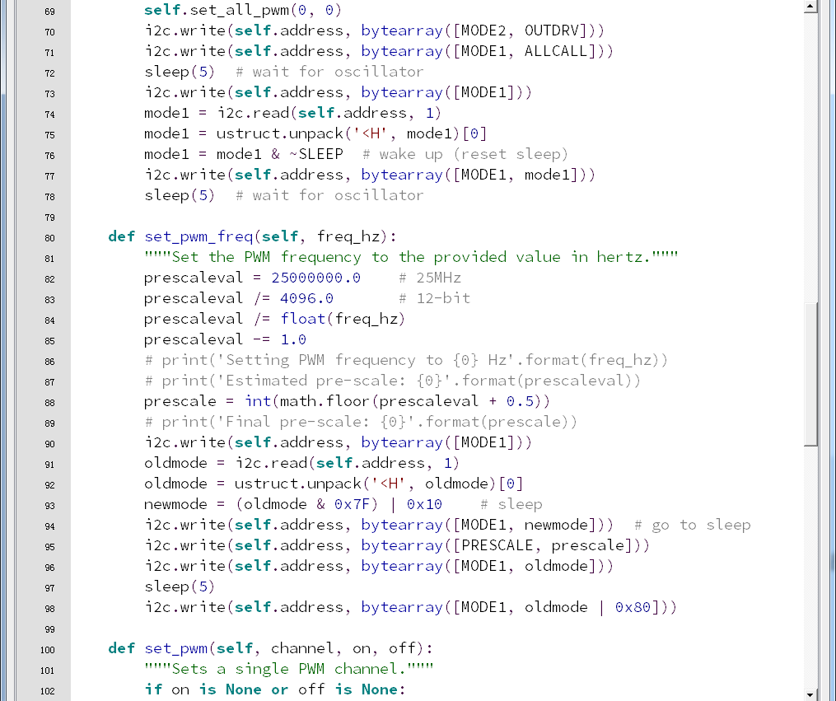
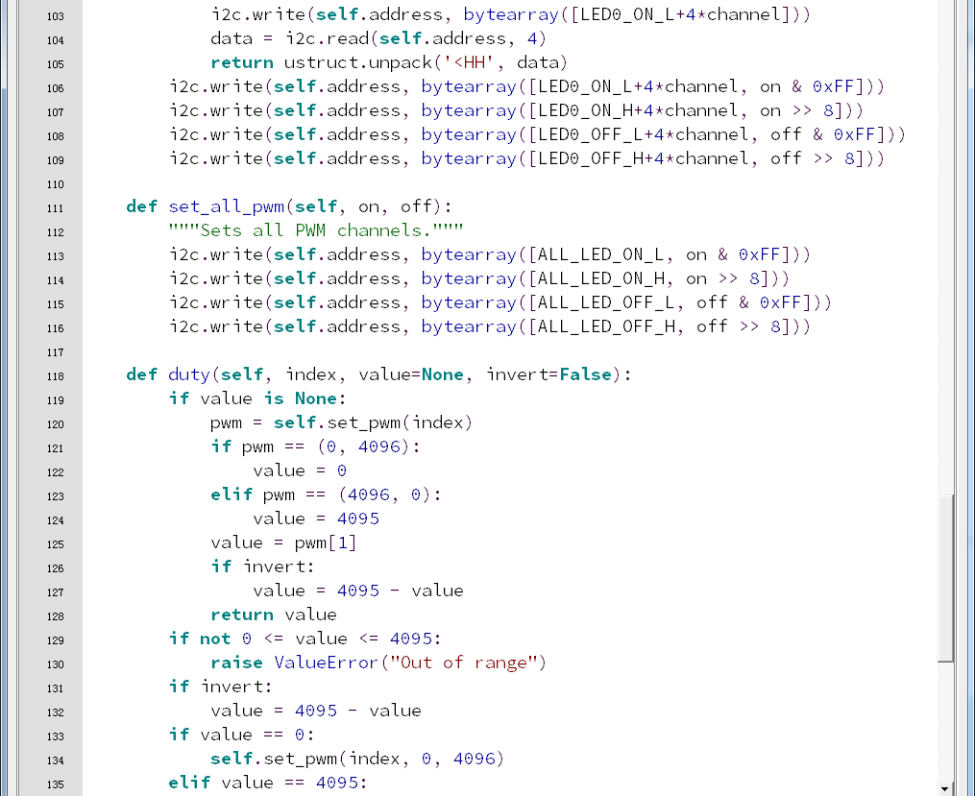
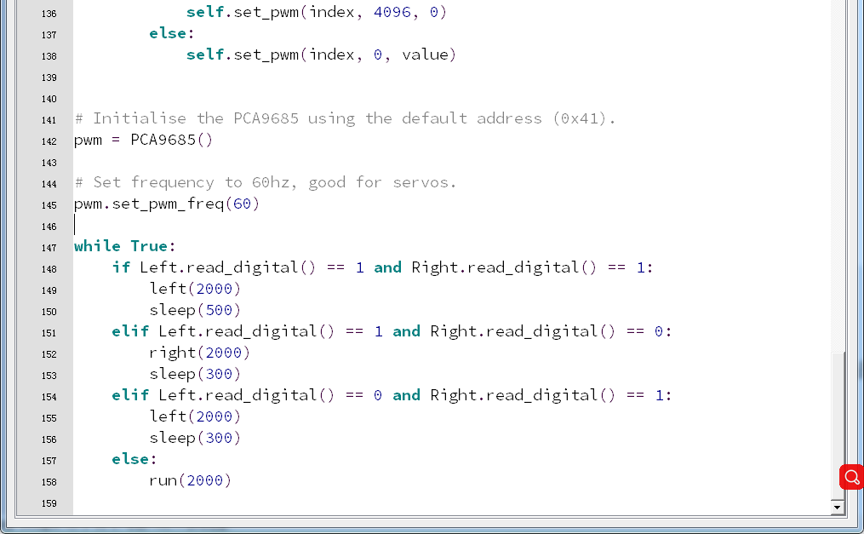
8-1-8
4.Download programming
You need to make sure that the micro:bit development board is connected to the computer. Then you should click on the download in the lower left corner as shown in 8-1-9 to download the program to micro:bit.

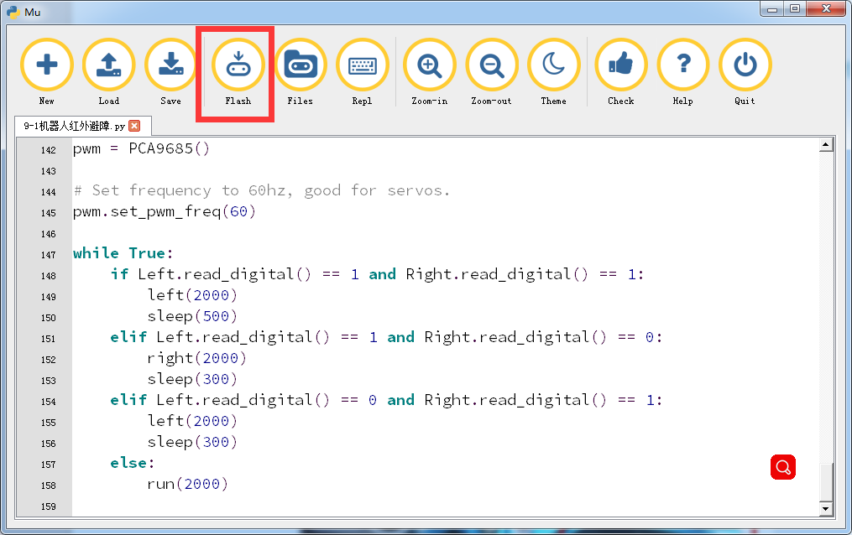
8-1-9
5.Phenomenon
After the code is uploaded. You can see that if there is an obstacle in front of the robot, the robot will turn right in place to avoid the obstacle; if there is an obstacle in the left front of the robot, the robot will turn right in place to avoid the obstacle; if there is an obstacle in the right front of the robot, the robot will turn left in place to avoid the obstacle.
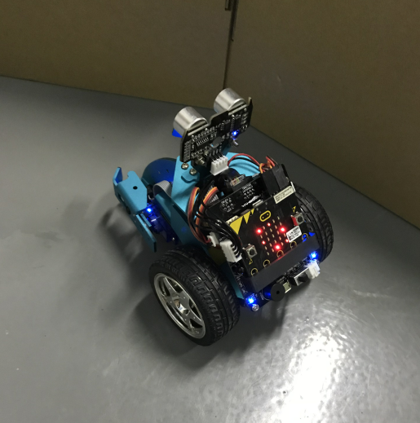
8-1-10

